Behaviour and Discipline Policy

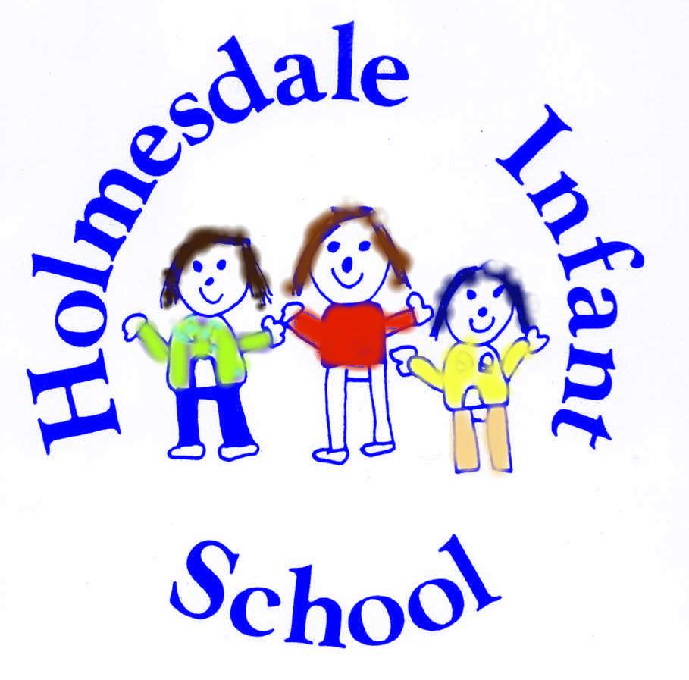

Redrafted | May 2023
Next review 2024

Mission statement
We believe good behaviour is an essential condition for effective teaching and learning to take place. At Holmesdale Infant School we believe that pupils and staff have the right to learn and teach in an environment that is safe, friendly, peaceful and fair as this in turn supports good well-being for all.
Good behaviour must be carefully developed and supported. High self-esteem promotes good behaviour, effective learning and positive relationships. The best results, in terms of promoting good behaviour arise from emphasising potential, rewarding success and giving praise for effort and achievement, rather than focussing on shortcomings and failure. Through the example of the adults who care for them at school, through well-planned and stimulating learning opportunities, we believe that children will accept learning challenges and develop self-discipline.
It is the responsibility of parents to share with the school in helping their children to behave well.
Legislation and statutory requirements
This policy is based on advice from the Department for Education (DfE) on:
- Behaviour and discipline in schools
- Searching, screening and confiscation at school
- The Equality Act 2010
- Use of reasonable force in schools
- Supporting pupils with medical conditions at school
It is also based on the special educational needs and disability (SEND) code of practice.

Aims
We believe good behaviour means that everyone in school is:
- Careful and kind.
- Polite and friendly.
- Helpful to each other.
- Quiet and hardworking.
- Respectful and tolerant.

The Policy

Our “Golden Rule” is simple:

“Be kind and try your best”

This will be reinforced by teaching and non-teaching staff throughout the day.

Staff will strive to take into consideration all aspects of a child’s life displaying empathy for contributing factors that may impact on a child and their well-being that could be causing challenging behaviour. Time will be given to children to discuss these moments allowing them to reason and consider why they may have acted in a certain way and what strategies can be used in the future to enable them to approach situations differently.

In addition to teaching social behaviour by drawing on incidents as they occur in the daily life of the school, teachers need to assume an active role in teaching social skills in a conscious and systematic way, using praise, a thank you, a show of affection or by showing good work in assembly or at another designated time.

Aims for Good Behaviour:
- Our aims are to work consistently and fairly on the positive management of behaviour.
- To help our children develop into caring and thoughtful people who respect and value the feelings, opinions, beliefs, property and differences of others.
- To encourage staff, children and parents to value good behaviour.
- To develop our children’s self-discipline.
- To build good well-being by helping our children to feel good about themselves and others.
- To encourage our children to co-operate with one another and with adults in the school.
- To create a positive and stimulating learning environment, having high expectations of children’s work.
- To work alongside parents to encourage our children to develop socially, personally, academically and morally in preparation for a positive role in society.
- To understand that bulling is not acceptable

Our Objectives
We support positive behaviour and a positive environment through:
- A consistent approach by the whole school community.
- Constructive whole school planning for PSHE.
- Appreciating and following agreed codes of behaviour.
- Encouraging our children to see themselves as a member of the school team and recognise their responsibility within this.
- Developing the skills of co-operation and discussion.
- Encouraging everyone to take care of and have respect for their own and each other’s belongings.
- Encouraging everyone to take pride in our environment.
- Having a positive and consistent approach to playtimes and lunchtimes.
- Creating a stimulating classroom environment.
- Providing clear and positive learning experiences fairly and consistently.
- Offering a broad and balance curriculum that is well prepared, planned and stimulating to each child.
- Ensuring that curriculum issues concerning organisation, methods of teaching and learning, content, and differentiation are addressed.

Procedures
Our School Community will:
• Apply the guidance contained in this policy;
• Engage pupils in discussions about behaviour using emotion coaching techniques where appropriate;
• Report significant incidents to the senior leadership team and record them on My Concern;
• Take responsibility for responding to the behaviour of pupils and take appropriate action;
• Promote positive behaviour through being good role models for others;
• Tackle any form of bullying in line with our anti-bullying child protection policies;
• Actively promote an inclusive ethos throughout school;
• Seek support, if unsure, from other members of staff
• Adopt child-centred approaches by listening to pupils and considering their perspectives.

Management of classroom behaviour
We encourage our class staff to reflect on what may be the underlying issues that drive or trigger behaviours in pupils, and to think about ways of responding to behaviour that challenge in a non-judgemental and supportive way. We recognise this can be very difficult and Senior Leaders / FSW are available to support. Any specific arrangements for individual pupils will be agreed in collaboration with the FSW and SLT.
Occasionally, the behaviour of children may escalate and become unsafe within a classroom. Children with this level of behaviour will require the involvement of the FSW and SENDCO who will coordinate an individualised response to behaviour through a risk assessment and SEND support plan. Persistent or severely unsafe behaviour may lead to implementation of exclusion procedures.

Roles and Responsibilities of staff
• Maintain clear and consistent boundaries with all children. Some children will require individualised approaches due to underlying additional needs and these will be determined in discussion with FSW / Senior Leadership;
• Be a role model for positive communication, care, connection and confidence.
• Actively build trust and rapport. Adults should listen respectfully to the pupil and make a judgement about how/when to respond.
• Maintain a calm and purposeful learning environment;
• Take responsibility for the behaviour of all pupils around school and deal appropriately with any incidents that occur;
• Monitor the behaviour of all pupils in class and report any significant incidents or concerns using My Concern via the safeguarding procedures in place;
• Monitor the impact of additional intervention and outside agency involvement on pupils in class and how it affects their readiness to learn;
• Ensure rewards are distributed regularly and inclusively by electing children for recognition in whole class celebration assembly.
• Where pupils have a significant level of social, emotional or mental health needs, staff, will adhere to the guidance of any risk assessments or outside agency advice that is collated and shared by the FSW / SENDCO
• Maintain clear and consistent boundaries with all children.
• Some children may require Individual behaviour plans. These will be discussed with all staff. ONE adult [the TA supporting the pupil] will be responsible for the rewards and sanctions of the pupil with an Individual Behaviour Plan. These may involve the Headteacher. They will also be the adult responsible for what can and cannot happen at break and lunch-times. These will be shared with staff as part of the plan. The whole school behaviour plan will still be followed with these pupils if they do not respond to the strategies set out in their individual plan.

The role of Senior Leaders
• To monitor the impact of this policy and review when required;
• Report on the effectiveness of this policy to Governors;
• Ensure staff access appropriate training and/or coaching regularly;
• Regularly discuss behaviour as part of the weekly safeguarding review meetings;
• Monitor any behaviour which may be causing concern across the school and take appropriate action to ensure that any impact on learning is minimised;
• Engage with families through person centred planning approaches whereby the needs of the child are placed at the centre of all decisions made;
• Coordinate any outside agency involvement which may be appropriate in meeting additional needs;
• Monitor pupil responses to this policy through the recording of significant incidents and analyse the impact on different groups of pupils to ensure that no specific group is unduly disadvantaged
• The Headteacher must be made aware of all meetings / conversations with parents / carers regarding behaviour beforehand. These conversations should then be logged on My Concern.

Role of Governing Body
• Delegating powers and responsibilities to the Headteacher to ensure all school personnel and visitors to the school are aware of and comply with this policy;
• Ensuring a high standard of provision throughout school;
• Scrutinising data presenting to the governing body regarding behaviour and safeguarding;
• Ensuring the school policies and practices comply with the SEN code of practice;
• Ensure that the school complies with all equalities legislation;
• Ensure funding is in place to support this policy;
• Ensure that this policy and all policies are maintained and updated regularly;
• Ensure all policies are made available to parents;
• Ensure that effective implementation, monitoring and evaluation of this policy takes place;

Rewards and Sanctions
There is a whole school strategy in place for rewarding the efforts and behaviour of pupils. Rewards are done through the use of a system of positive recognition of individual children or whole class’s achievements. These are recognized in celebration assembly where badges and certificates are given.
We will also have a half-termly reward for children who have not gone past step 4 of our behaviour process. Staff will keep a record of each step of the process for each child so that this is completely transparent to the pupils. The planned reward will be shared with the children at the beginning of each half-term and may include a games afternoon, film afternoon, visit from the ice cream van, outside play activities etc. Children who exceed step 4 of the behaviour process will not take part in this, but will work with the HT and FSW in school, sharing strategies for how to ensure that they receive the reward the next time. Each half-term will be a ‘clean slate’ and children will start again. Staff members are committed to positive recognition for what pupils can do and for the individual steps each child makes towards their goals. This can be in the form of a positive comment, sharing work or recognition with another member of staff, a positive e-mail or phone call home.
We actively encourage staff to show children the right thing to do by maintaining boundaries and staff are expected to be firm, fair, calm and consistent in their approach and explaining the consequences of choice, both positive and negative.
Staff should use specific descriptive praise when we see them making a good choice and link consequences to the choices they make, to help them make the best choice. For example:
“I liked that you asked for a break when you needed it.”
“I noticed you were being a good friend by helping Sam.”
“Thank you for coming back to your work so quickly.”
It is important that pupils are supported to understand that inappropriate behaviour has consequences.

Poor behaviour choices will be dealt with as follows:
- Verbal warning 1
- Verbal warning 2
- Verbal warning 3, time out within the classroom
- Verbal warning 4, time out in another classroom
- Loss of social time in the lunch break to be followed by time with the FSW/DHT. Logged on My Concern by class teacher. Phone call / contact with parent by teacher.
If poor behavior persists:
- Conversation with HT. Possible consequences explained to pupil. Internal exclusion from all social time one day [break and lunch-time] Decision to involve Behaviour support, Ed Psych if necessary. Logged on MyConcern by HT. Phone call home by HT.
- Phone call home by HT. Internal exclusion for 2 days. Logged on MyConcern by HT
- Fixed term exclusion [2 days] Logged on MyConcern by HT
- Fixed term exclusion [5 days] Logged on MyConcern by HT

The HT will decide the consequence of extreme behaviour [physical injury / bad language / consistent low level disruption] in discussion with the class teacher.

The range of sanctions include:
- Non-verbal signals.
- Verbal warning, reminding the child of our expectations/rules.
- Private discussion about why the behaviour is unacceptable, and giving the consequences of further poor behaviour.
- Change of position within the learning environment.
- Separating a child from a group or the class.
- Loss of privileges i.e. walk around at playtime holding someone’s hand.
- Time out procedures.
- Using a home school diary
- Contacting parents to discuss ways of helping the child to improve his/her behaviour.
- Referring the child to the Headteacher or Deputy Headteacher. (Severe mis-behaviour)
- Referring the child to the SENCO/Headteacher (Special Educational Needs Co-ordinator) with a view to devising an ‘individual behaviour programme’, to help the child learn appropriate social behaviour in school.
It is possible for the sanctions to start at any level depending on the nature of the unacceptable behaviour.

In cases where behaviour is extreme or escalates to the point where the safety of other children at play is compromised then parents may be asked to collect their child from school and take home during lunchtime for an agreed period of time. This will be considered a fixed-term exclusion and will be recorded against the pupil.
Staff at school are able to use ‘reasonable force’ to prevent injury, damage to property or disorder. Schools can use reasonable force to [for example]:
- Remove disruptive children from the classroom when they have refused to follow an instruction to do so
- Prevent a pupil behaving in a way that disrupts a school event or school trip / visit
- Prevent a pupil leaving the classroom where allowing the pupil to leave would risk their safety or lead to behaviour that disrupts the behaviour of others
- Prevent a pupil from attacking a member of staff or another pupil, or to stop a fight
- Restrain a pupil at risk of harming themselves through physical outbursts [DfE Use of reasonable force advice July 2013].
This will always be a last resort. We will never use unnecessary force and we will never use force as a punishment. Serious incidents that necessitate the use of restraint will be shared with parents.

ALL cases of discriminatory language, child on child abuse or serious physical injury will be referred to the HT, who will decide on the course of action to be taken [See Appendices A and B].

School will work with parents to try and prevent this from happening, but in exceptional cases must protect the safety of other children during a time in the day where members of staff may be unavailable to deal with incidents and support lunchtime staff.

- For extreme and / or consistently dangerous, unacceptable and unsafe behaviour a temporary or permanent exclusion may be actioned in line with legal requirements
Deliberate physical harm to another child will not be tolerated and will result in an immediate conversation with the HT and loss of playtime with time-out inside. Such behaviour will be logged on My Concern and parents informed.

When discussing behaviours/reactions we refer to the health and safety and the impact the situation may have had on all involved or nearby. This discussion sometimes has to happen after an event, when the pupil is regulated and able to reflect upon their behaviour. In such circumstances, staff should inform the child that their behaviour is inappropriate and that it will be spoken about later.

• Teaching staff will avoid any actions which lead to unnecessary shaming or humiliation of the child.
• The specific needs of the child will be considered when deciding appropriate next steps for the child;

We recognise that a one size fits all approach is not appropriate for our pupils.
Other sanctions may include:

• Cautionary advice
• Educational intervention
• Reporting to parents
• Enhanced supervision
• Restrictions on movements within the school
• Suspension
• Exclusion

Exclusions and alternative provisions
In exceptional circumstances, when the behaviour of individual pupils places others at risk of harm then exclusion procedures may be implemented, however, further action is always taken to ensure that plans are in place to meet the needs of these individual pupils.

Staff training
All staff have accessed training in emotion coaching. This guides them to discuss behaviour with individual children and find solutions that enable pupils to manage their own behaviour effectively and make good choices.
Whilst these approaches can be used by all members of staff, we recognise that individual children may require an individualised approach from staff. This is coordinated by the HT/ FSW / SENDCO and may require consultation with outside agencies or our Educational Psychologist. When outside agencies are involved and provide guidance or advice, this information is shared with key members of staff to ensure that appropriate provision is made for pupils in school.

Pupil support systems
We implement a wide range of support systems for pupils who are having difficulty in achieving successful behaviour for learning. Some of these include the following;
• Individual reward systems or tracking systems
• One to one support with the FSW or other appropriate TA.
• Mindfulness
• Cosy Corner/Colour Monster
• Peer support i.e. playground buddies
• Nurture
• Positive play
• Playdough therapy

Managing Pupil Transitions
We understand that moving up to a different class or school can be a stressful time for children and we aim to ensure that the level of support required is provided to individual pupils. The use of enrichment days allows our pupils to get to know other staff and rooms.
Pupils joining in reception have the opportunity to visit school three times before starting and during the first week of the autumn term reception staff do home visits to help establish relationships.
Pupils with SEND are actively encouraged to take up additional sessions and support to develop their understanding such as visual transition booklets.
Relevant members of staff liaise with staff at feeder settings and also visit children there during July. This ensures that information is shared effectively in order to plan the most appropriate provision.

For children moving to junior school visits and activities are planned during the Summer 2 term. Teachers and SENDCO ensure all information regarding needs is passed on and where necessary additional visits are planned in.

Working with families
At Holmesdale Infant School we understand the importance of working together with families to ensure the best outcomes for our pupils. If the behaviour of individual pupils becomes a concern then we will meet with parents and/or carers at the earliest opportunity in order to plan effectively. If families require additional support, then we can offer this through the Schools Family Support Worker and / or Early Help Assessment Tool.

APPENDIX A: Managing child on child abuse
Child on child abuse can be defined as [but not limited to]:
- physical and sexual abuse.
- sexual harassment and violence [unwanted conduct of a sexual nature such as sexual comments, sexual jokes or taunting, up-skirting, physical behaviour like interfering with clothes or online harassment].
- emotional harm.
- on and offline bullying.
- teenage relationship abuse.

Our ethos is based on a culture of respect, acceptance, and diversity. Any incidents of child on child abuse will not be tolerated. The school’s response will be proportionate, considered, supportive and decided on a case-by-case basis. The school will use the guidance set out by the Local Authority to deal with all allegations.

Curriculum
The school’s RSE and PSHE curriculum is focused on healthy relationships and teaching the values of respect, acceptance and diversity. All children will be educated through the school curriculum to understand these values (see PSHE/RSE curriculum).

Reporting
• All incidents of child on child abuse should be recorded on My Concern by staff and reported immediately to the safeguarding team.
• Staff should be alert to any ‘lower level’ incidents of sexualised language/sexism. These incidents should be tackled through educating the child and reporting to the DSL.
• Children should understand that any incidents of child on child abuse should be reported to a member of staff immediately.
• The safeguarding team will review weekly any incidents of child on child abuse and identify and respond to any patterns.

Responding to incidents
All staff will be trained and will know how to report and respond to any incidents.
Incidents will be considered on a case-by-case basis, taking into account the age and developmental stage of the child who has been harmed and the child who has harmed.
The child who has been harmed and the child who has harmed will be given a safe space with at least two members of staff to explain the incident.
Significant incidents of sexualised behaviour will be assessed by the safeguarding team.
Following this assessment the team will decide on appropriate actions and sanctions. These must always take into account the views of the child who has been harmed and the child who has harmed and be proportionate.
They may include:
• Cautionary advice
• Educational intervention
• Reporting to parents
• Involvement of social care
• Enhanced supervision
• Restrictions on movements within the school
• Use of a Risk Assessment
• Suspension
• Exclusion

Support for the child who has been harmed
Support will be provided for the child who has been harmed in discussion with the child and parents/carers as appropriate.

This may include:
• Therapy provided by the school or outside agencies
• Educational intervention
• Additional support from school staff for the child and parents/carers

Support for the child who has harmed
Support for the child who has harmed will be in discussion with the child, safeguarding team, SLT, parents/carers, police and social care as appropriate. This support may include:
• Therapy provided by the school or outside agencies
• Educational intervention
• Additional support from school staff for the child and parents/carers

APPENDIX B: Managing Discriminatory Language

Educating your pupils, staff and parents helps tackle all forms of discrimination, protective factors such as racism, sexism or ableism. Stopping these behaviours early can help to educate and prevent more serious forms of abuse and discrimination from taking root.

At Holmesdale we have due regard for:
• Eliminating discrimination
• Advancing equality of opportunity
• Fostering good relations in your community

Guiding principles when challenging behaviours
It is recognised that there’s no “one size fits all” approach to these conversations. Staff and leaders need to judge the most appropriate way to raise the topic, depending on the situation. These are the principles we will use when dealing with these behaviours

1. Don’t let it go if you hear or see a pupil or a member of staff saying or doing something that feels sexist, racist or discriminatory in any way, respond to the situation there and then. By doing nothing, you’re sending the signal that you’re okay with what you’ve witnessed.

2. Be reasonable - Make sure your response to anything seen or heard is proportionate. If you have a zero-tolerance approach to even the most minor of comments, pupils are unlikely to be honest with you or feel they can talk to you about these issues. Explain why the behaviour is inappropriate and accept that a conversation may be all that's needed.

3. Handle incidents calmly - Depending on the severity of what you’ve witnessed, reacting immediately with anger or harsh discipline will likely cause the pupil to become aggressive and defensive in turn. If appropriate, turn the situation into a teachable moment. Explain why what was said or done was inappropriate and encourage a conversation rather than just handing out punishment. Stop the behaviour right away but pick up with an individual child have the conversation later when the child is calm and away from peers.

4. Be precise - Always explain exactly what was inappropriate, in as much detail as possible, so there’s no room for doubt. Depending on the age of the pupil, you might want to say something like: “Do you know what [that word] means? [Explain in age-appropriate terms, if necessary] You might hear and use that word at home, but it can offend and hurt some people so we don’t use it in school.”

Reporting
• All incidents of discriminatory language should be recorded on My Concern by staff and reported immediately to the safeguarding team.
• Staff should be alert to any ‘lower level’ incidents. These incidents should be tacked through educating the child and reporting to the DSL.
• The safeguarding team will review weekly any incidents of discriminatory language and identify and respond to any patterns.

Responding to incidents
• All staff will be trained in understanding and managing discriminatory behaviours. They will know how to report and respond to any incidents.
• Incidents will be considered on a case-by-case basis, considering the age and developmental stage of the child who has been affected and the child who has harmed.
• The child who has been harmed and the child who has harmed will be given a safe space to explain the incident.
Following this assessment the team will decide on appropriate actions and sanctions. These must always take into account the views of the child who has been harmed and the child who has harmed and be proportionate.

They may include:
• Cautionary advice
• Educational intervention
• Reporting to parents
• Involvement of social care
• Enhanced supervision
• Restrictions on movements within the school
• Suspension
• Exclusion

Support for the child who has been harmed
Support will be provided for the child who has been harmed in discussion with the child and parents/carers as appropriate. This may include:
• Therapy provided by the school or outside agencies
• Educational intervention
• Additional support from school staff for the child and parents/carers

Support for the child who has harmed
Support for the child who has harmed will be in discussion with the child, safeguarding team, SLT, parents/carers, police and social care as appropriate. This support may include:
• Therapy provided by the school or outside agencies
• Educational intervention
• Additional support from school staff for the child and parents/carers

